The Impact of Global Commodity Prices on Macroeconomic Indicators
An Econometric Analysis for India and the USA (2010–2023)


Submitted By:
Harshita Pal
MDB24012
Indian Institute of Information Technology, Lucknow
25-11-2025

Table of Contents

Abstract 3
Description of the Data Set 3
Research Problems 5
Hypotheses 5
Data-Analysis Plan 6
Exploratory Data Analysis (EDA) 7
Recommendations 24
Limitations 25

Abstract
This report investigates the dynamic impacts of global commodity prices—including energy, agricultural, and precious metals—on key macroeconomic indicators in India and the USA from 2010 to 2023. Using a combination of exploratory data analysis, multiple linear regressions, and time-series ARIMA modeling, we test several hypotheses about cost-push inflation, economic growth sensitivity, and asset flight in volatile markets.
Our results reveal significant cross-country differences in macroeconomic responses to global price fluctuations. India’s inflation and interest rates are strongly affected by commodity shocks, consistent with its higher import dependence, whereas the USA’s advanced economic structure exhibits greater insulation. Regression models highlight energy price shocks as significant predictors of India’s economic growth and domestic inflation, while precious metals like gold do not show robust statistical correlation with stock market indices in either country.
These findings carry important implications for economic policy, risk management, and strategic planning, particularly for emerging markets exposed to commodity volatility. The analysis also underscores the limitations of linear and autoregressive models in capturing complex, multi-factor macroeconomic phenomena—suggesting directions for future research and data-driven policymaking.

Description of the Data Set
This study utilizes a robust panel dataset constructed by merging secondary data from two high-reliability sources: the World Bank’s Commodity Markets Outlook (CMO) and the Global Economic Indicators dataset sourced from Kaggle. The final integrated dataset spans a fourteen-year period from 2010 to 2023, enabling a longitudinal analysis of the interaction between global commodity price movements and national macroeconomic performance.

Source 1: Global Economic Indicators (Macroeconomic Data) | Source
The primary source for country-level economic performance is the "Global Economic Indicators Dataset 2010-2023," compiled by Heidar Mirhajisadati [1]. This dataset provides a granular view of macroeconomic health across various nations. It includes seven key variables:
- Country: The unique identifier for the nation being observed.
- Date/Year: The temporal reference for observation, spanning from 2010 through 2023.
- GDP Growth Rate (%): The annual percentage growth in Gross Domestic Product, serving as the primary metric for economic expansion or contraction.
- Inflation Rate (%): The rate at which the general level of prices for goods and services is rising, indicating purchasing power stability.
- Unemployment Rate (%): The percentage of the total labor force that is unemployed but actively seeking employment.
- Interest Rate (%): The central bank's lending rate, a critical tool for monetary policy and inflation control.
- Stock Index Value: A composite value representing the performance of the country's major stock market, reflecting investor confidence and financial market health.

Source 2: World Bank Commodity Markets Outlook (Commodity Price Data) | Source
To capture global market volatility, historical price data was sourced from the World Bank’s "Pink Sheet" (CMO Historical Data - Monthly)[2]. This extensive dataset tracks the nominal prices and indices of major global commodities. Key columns utilized in this analysis include:
- Date/Year: The data captures monthly data, spanning from 1960 through 2024.
- Energy Index: A composite index tracking prices of crude oil, natural gas, and coal.
- Non-Energy Index: A broad index covering agriculture, fertilizers, and metals.
- Agriculture Index: Tracks prices of food, beverages, and raw agricultural materials.
- Metals & Minerals Index: Covers base metals like copper, aluminum, and iron ore.
- Precious Metals Index: Tracks safe-haven assets such as gold and silver.
- Specific Commodity Prices: Nominal prices for critical individual commodities such as Crude Oil (Brent/WTI), Gold, and Natural Gas, measured in nominal US Dollars (USD).

Data Integration and Preprocessing -
A critical step in the data preparation involved harmonizing the datasets to a consistent monthly frequency to capture high-frequency market volatility.
- Filtering: The macroeconomic dataset was filtered to isolate observations for specific countries separately.
- Frequency Alignment: Since macroeconomic indicators (like GDP and Inflation) were reported annually, while commodity prices were reported monthly, the macroeconomic data was resampled to a monthly frequency. A forward-fill method was utilized to propagate the annual indicators across the corresponding months.
- Merging: To construct a consistent time-series, the annual macroeconomic data for India was resampled to a monthly frequency. Unlike simple repetition (like ffill()), a linear interpolation method was applied to estimate the intermediate monthly values. This technique creates a smooth, continuous progression of economic indicators (such as GDP and Inflation) between the annual data points, avoiding artificial "steps" in the data.

Research Problems
The primary objective of this study is to perform a comparative econometric analysis of how global commodity market volatility impacts the macroeconomic performance of a developing economy (India) versus a developed economy (USA). By utilizing separate regression models for each macroeconomic indicator, this research seeks to answer the following questions:
1. Comparative Impact of Energy Prices on Economic Growth
- Research Question: How does the impact of global crude oil, natural gas prices on GDP Growth differ between India (a major net energy importer) and the USA (a major energy producer)?
- Investigative Angle: Does a rise in energy prices act as a significant drag on India's GDP while potentially having a neutral or positive effect on the USA's GDP?
2. Commodity-Driven Inflation Dynamics
- Research Question: To what extent do global commodity price shocks (specifically Energy, Metals, and Agriculture) translate into domestic inflation in both nations?
- Investigative Angle: Is the "pass-through" effect of global raw material costs to domestic consumer prices (Inflation Rate) stronger in India compared to the USA?
3. Financial Market Correlations and Safe Haven Assets
- Research Question: How do the prices of precious metals (Gold, Silver) influence the Stock Index performance and Unemployment Rates in these two distinct economic environments?
- Investigative Angle: Do separate models reveal a stronger inverse relationship between "safe haven" assets (Gold) and equity markets in one country over the other during periods of volatility?

Hypotheses
To address the research questions effectively, distinct hypothesis sets are formulated for the separate models of India and the USA. These hypotheses test the directional impact of commodity price volatility on specific macroeconomic indicators.
Hypothesis Set 1: Energy Prices and GDP Growth
- H0 (Null): Fluctuations in global energy prices (Crude Oil) have no statistically significant impact on the GDP Growth Rate of either India or the USA.
- H1(a) (Alternative - India): An increase in global energy prices has a significant negative impact on India's GDP Growth Rate (reflecting its status as a net energy importer).
- H1(b) (Alternative - USA): An increase in global energy prices has a positive or neutral impact on the USA's GDP Growth Rate (reflecting its domestic energy production capacity).
Hypothesis Set 2: Commodity Prices and Inflation (Cost-Push Effect)
- H0 (Null): There is no significant causal relationship between global commodity indices (Energy, Agriculture, Metals) and domestic Inflation Rates in either country.
- H1 (Alternative): Increases in global commodity prices are positively correlated with domestic Inflation Rates in both nations, but the magnitude of this coefficient is expected to be higher for India due to higher import sensitivity.

Data-Analysis Plan
To test the hypotheses and ensure robust results, the analysis follows a structured econometrics framework. The process is divided into four distinct phases.

1. Exploratory Data Analysis (EDA)

a) Descriptive Statistics
- Compute and summarize statistics (mean, median, stdev, min, max, quartiles) for all numeric fields, for both countries and each data domain.
- Present summary tables for macro indicators and major commodities to give an overview of data distributions.

b) Time Series Visualization
- Generate line graphs for each key macroeconomic and commodity variable over time.
- Visualize and compare temporal trends and volatilities (e.g., stock index vs. commodity prices, inflation spikes, etc.).
- Use seasonal plots if periodicity is suspected in any variable.

c) Distribution Analysis
- Plot histograms to check data skewness/kurtosis for each variable.
- Assess normality visually and statistically as needed.

2. Correlation and Heatmap Analysis
- Compute the Pearson correlation matrix between all macro indicators and commodity prices, separately for India and USA.
- Visualize using annotated heatmaps for each country:
  - Highlight strength, direction, and patterns of associations (e.g., oil and inflation, gold and stock index, etc.).
  - Interpret country-specific differences and consistencies in correlation values.
- Discuss meaningful clusters or outlier relationships revealed by heatmaps.

3. Feature Engineering & Data Preparation
- Standardization/Normalization: Scale features for comparability, especially prior to regression modeling.
- Handling Seasonality/Stationarity:
  - Apply stationarity checks (ADF tests) before time-series modeling.
  - Detrend or difference series as appropriate.

4. Statistical and Predictive Modeling

a) Regression Modeling
- For each macro target variable (e.g., GDP Growth, Inflation, Unemployment), build multiple linear regression models using the set of commodity prices as predictors.
- Perform:
  - Train-test splits to evaluate generalization.
  - Diagnostic checks (MSE, R², residual histograms).
  - Statistical significance and confidence intervals for coefficients.
- Present a summary table of model scores for all targets (both countries) to compare fit and predictive power.

b) Time Series Modeling
- Where relevant (e.g., for univariate analysis or forecasting: unemployment or inflation), test and build ARIMA models.
- Include ADF test summaries to justify ARIMA use.
- Report model diagnostics: AIC, BIC, residual distribution, test/train metrics, and forecast accuracy.

Exploratory Data Analysis (EDA)
The exploratory phase focused on visualizing the temporal dynamics and structural relationships between global commodity markets and the macroeconomic performance of a developing net-importer (India) versus a developed net-producer (USA). This comparative analysis reveals distinct transmission mechanisms for global shocks.

1. Trend Comparison: Crude Oil Prices vs. GDP Growth

India: Impact of Crude Oil on GDP Growth (2010–2023)
- Trends & Co-movements: The plot shows GDP growth rate (red solid line, left y-axis) and crude oil price ($/bbl, blue dashed line, right y-axis) over time.
During periods of rising crude oil prices (e.g., 2010–2012, 2021–2022), there is often an observable dip in GDP growth, especially around oil price peaks. Conversely, when oil prices fall (2014–2016), GDP growth generally rebounds.
- Volatility: GDP growth in India exhibits large swings, with periods where growth falls below zero, particularly after sharp increases in crude oil prices or global oil shocks.
The graph illustrates several instances (e.g., 2014, 2020–2021) where global events (oil crash, pandemic) affected both oil price and economic growth.
- Economic Sensitivity: India’s economy is heavily dependent on oil imports, so rising oil prices tend to increase input costs for businesses, raise inflation, and put downward pressure on growth.
- Lag Effects & Policy Implications: The relationship may not always be immediate; there can be lags as oil price shocks work through supply chains and policy responses.
- Key Takeaway: The time series visual confirms a negative relationship between crude oil prices and GDP growth—higher oil prices broadly correlate with lower or more volatile Indian GDP growth. This sets the stage for regression and causality analysis in subsequent modeling.

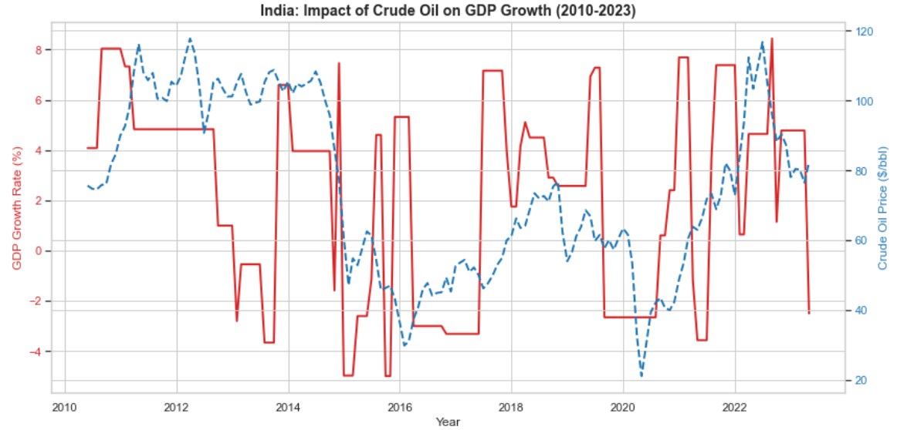
Figure 1(b)

USA: Impact of Crude Oil on GDP Growth (2010–2023)
- Trends & Co-movements: Similarly, the USA plot presents GDP growth rate (red line) and crude oil price ($/bbl, blue dashed line) over the same period.
There are fewer extreme swings in GDP growth compared to India, though identifiable dips correspond to spikes in oil price (2012–2013, 2020).
- Resilience & Volatility: US GDP growth is more stable, with growth rarely falling well below zero except during major global crises (e.g., pandemic in 2020). This suggests greater economic resilience or mitigation against oil price shocks due to more diversified energy sources, domestic production, and economic structure.
- Notable Observations:
  - Around 2015–16, a sharp drop in oil prices coincides with modest improvement in GDP growth.
  - In 2021–22, a sharp oil price rebound is visible, coinciding with mixed GDP growth response.
  - US policy responses (e.g., strategic reserves, domestic shale) may buffer the GDP from direct impacts of oil price shocks.
- Key Takeaway: The graph demonstrates that the USA’s GDP growth is less sensitive to crude oil price fluctuations compared to India. While negative correlation is present, the effect is dampened by structural factors, highlighting different economic vulnerabilities.

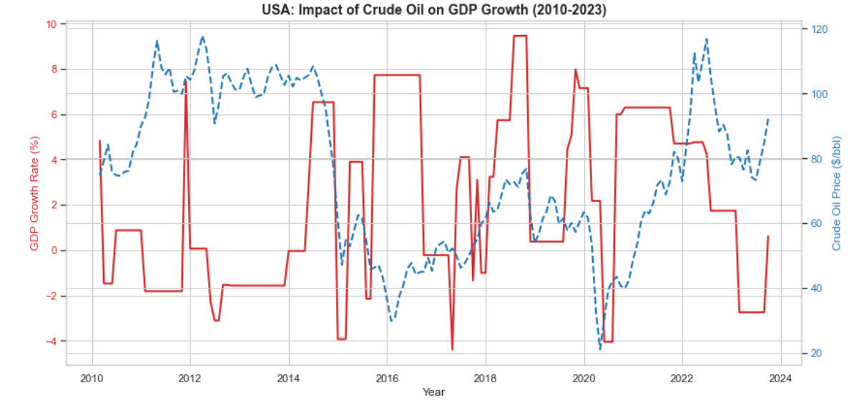
Figure 1(b)

Comparative Synthesis
- India vs USA Sensitivity: India’s GDP growth is more closely and negatively impacted by oil price shocks, due to its dependency on imported energy and narrower economic buffers. The USA, with greater domestic oil production and flexible energy markets, shows less extreme variation in GDP growth in response to oil price changes.
- EDA Implications: These visualizations justify modeling crude oil price as a key explanatory variable for GDP growth—especially for energy-dependent economies like India. They also motivate further analysis of policy, alternative energy adoption, and sectoral dynamics in both countries.

The time series trends underscore fundamental differences in the relationship between crude oil prices and GDP growth for India and the USA, with India revealing pronounced sensitivity and volatility to oil price changes, while the USA exhibits more resilience. These visual insights guide hypothesis formation and support the econometric investigation of macro-financial linkages and external shocks in comparative context.

2. Scatter Plot Comparison: Pass-Through of Energy Prices to Inflation

India: Pass-Through of Energy Prices to Inflation
- Positive Relationship: The scatterplot shows a clear positive correlation between global crude oil prices ($/bbl, x-axis) and domestic inflation rate in India (% y-axis). As crude oil prices rise, the domestic inflation rate also tends to increase.
- Regression Line: The fitted red regression line and shaded confidence interval reinforce this upward trend. The line's slope confirms that periods of higher global oil prices typically correspond to elevated inflation readings in India.
- Spread and Outliers: While there is some spread in the data (inflation rates for a given oil price vary), the overall pattern holds. A few outliers exist, particularly at very high inflation rates (~10%) even when oil prices are moderate.
- Economic Interpretation: This is consistent with the macroeconomic reality that India is highly sensitive to global energy prices due to its substantial oil import dependency. Increases in oil prices quickly pass through into transport, manufacturing, and consumer goods costs, driving headline inflation.
- Policy Implications: The positive pass-through indicates that managing or hedging oil price shocks is critical for stabilizing inflation in India. Policymakers and businesses need to monitor commodity price trends closely.
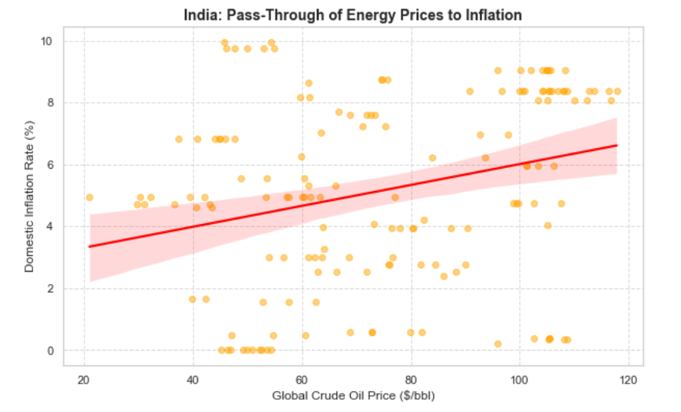
Figure 2(a)

USA: Pass-Through of Energy Prices to Inflation
- Weak/Negative Relationship: Contrasting with India, the USA scatterplot displays a weak and slightly negative correlation between global crude oil prices and domestic inflation rate. The fitted regression line slopes downward, though the effect is mild and the confidence band is wide.
- Data Dispersion: Points are widely dispersed, with inflation rates spread across the full range of oil prices. This suggests less direct or less predictable transmission of energy price changes into domestic inflation.
- Economic Interpretation: The muted and sometimes inverse relationship reflects structural differences in the US economy. The USA relies more on domestic oil production and is less exposed to import price shocks. Further, energy costs make up a smaller share of the consumer expenditure basket, and monetary policy tools can buffer inflation.
- Policy Implications: The lack of strong pass-through implies inflation management in the USA is comparatively independent of global crude price movements, focusing more on domestic supply/demand, labor markets, and monetary policy.

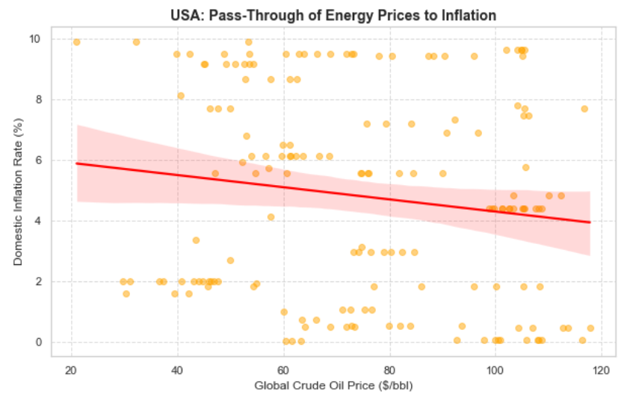
Figure 2(b)

Comparative Synthesis
- India vs USA: India shows a pronounced, positive pass-through from global energy prices to inflation—a critical vulnerability in economic management. The USA’s inflation is less sensitive and even occasionally inversely correlated to oil price changes, reflecting energy independence and diverse economic structure.
- EDA Significance: These visual results justify more in-depth quantitative modeling (regression, Granger causality) to estimate the strength and timing of the oil-inflation relationship. They also support comparative economic analysis in your report.

The scatterplots illustrate contrasting energy price pass-through to inflation for India and the USA. In India, rising global crude oil prices strongly drive higher inflation, confirming the vulnerability of an oil-import-dependent economy to external shocks. In the USA, no clear pass-through is visible—domestic inflation rates are relatively stable or even decrease during periods of high oil prices, suggesting other macroeconomic buffers and policy interventions are more influential. These insights motivate further econometric investigation into commodity price transmission mechanisms and their policy relevance.

3. Scatter Plot Comparison: Safe Haven Dynamics (Gold vs. Stock Markets)

India: Safe Haven Test (Gold vs. Stock Market)
- Relationship Overview:
The scatterplot examines the association between gold price ($/troy oz, x-axis) and India’s stock index value (y-axis). Each purple dot represents a monthly data point, while the green regression line indicates the general direction of the relationship—with its shaded area visualizing the confidence band.
- Trends & Insights:
The regression line shows a slight positive slope, suggesting a weak positive correlation between gold prices and the stock index. Increases in gold price are, on average, associated with a modest increase in stock market value. However, the wide spread and vertical dispersion of points reveal high variability—there are periods when gold rises but the stock market falls, and vice versa.
- Safe Haven Properties:
Gold is commonly considered a "safe haven" asset—that is, it should rise when the stock market falls as investors seek stability during market stress. The observed weak positive relationship implies that in India, gold does not consistently act as a safe haven in relation to equity market fluctuations over the sample period. Both assets sometimes move together or independently, and diversification benefits may be limited in crisis periods.
- Interpretation:
This visual analytic suggests that gold's role as a protective hedge against Indian stock market volatility is less pronounced than often assumed, warranting further investigation with crisis period analysis or more advanced econometric methods.
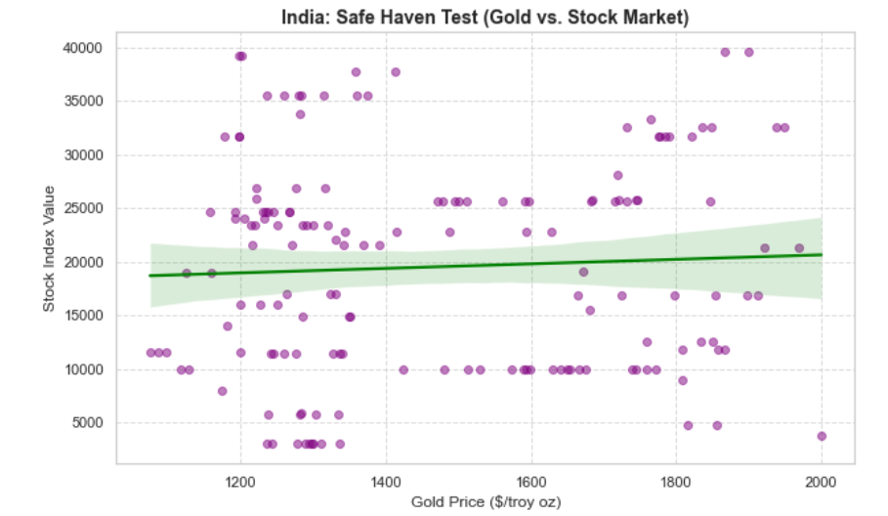
Figure 3(a)

USA: Safe Haven Test (Gold vs. Stock Market)
- Relationship Overview:
The USA scatterplot analyzes the same relationship for the American market. The regression line is again positively sloped, and its confidence interval is narrower, signaling a somewhat stronger and clearer relationship compared to India.
- Trends & Insights:
There is a moderate positive association between gold prices and the US stock index value. Periods of rising gold prices tend to be accompanied by higher stock index values, rather than moves in opposite directions.
- Safe Haven Properties:
This result is somewhat unexpected—a classic safe haven should be negatively correlated with equities. Instead, in the USA, gold and stocks have moved in tandem for much of the period, possibly due to simultaneous flight-to-safety and liquidity surges during crises (e.g., when monetary easing boosts both gold and equities).
- Interpretation:
The positive relationship invites further analysis. It suggests that gold has not played the traditional safe haven role for US investors during the observed decade, at least on a monthly timescale. This finding should be tested with sub-period or crisis-event analysis to confirm if gold's hedging properties emerge only during acute market stress.

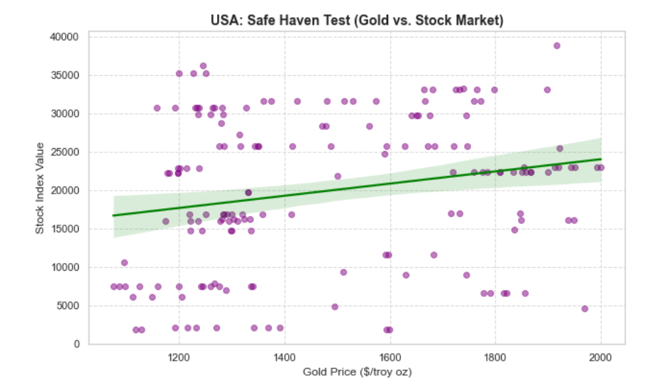
Figure 3(b)

Comparative Insights:
- India vs USA:
Both countries exhibit weak to moderate positive correlation—contrary to safe haven theory. The phenomenon may be driven by synchronized global monetary factors, investor sentiment, or data frequency. The USA’s gold-market relationship is slightly stronger and more stable, but neither country sees gold act as a clear inverse hedge against stock market drops.
- Implications for Further Analysis:
These results challenge conventional assumptions and motivate deeper examination into gold’s behavior during specific periods (e.g., global financial crises, pandemic shocks), different time frequencies, and policy regimes.

The Gold vs Stock Market scatterplots for India and USA reveal that, contrary to classic safe haven theory, gold has shown a weak to moderate positive relationship with equity index values for both countries over the past decade. This suggests that gold did not universally act as a counter-cyclical hedge to equity risk in monthly data, highlighting the need for nuanced and crisis-specific analysis of asset diversification and protection strategies.

4. Correlation Matrix Analysis (Heatmap Insights)
The Pearson Correlation Matrices (Figures 4a and 4b) quantify the linear relationships between global commodity prices and domestic macroeconomic indicators. A comparative assessment reveals distinct structural differences between the two economies.
India: Macro Indicators vs Commodity Prices
The correlation matrix for India reveals several important relationships between key macroeconomic indicators and a wide selection of commodity prices:
General Patterns:
- Most correlations are positive and moderate, suggesting that increases in commodity prices tend to be associated with rises in macro indicators such as inflation, GDP growth, unemployment, and interest rate.
- The stock index value, however, frequently displays weaker and sometimes negative correlation with several commodities, indicating a more complex or even inverse relationship.
Highlights & Insights:
- Inflation Rate (%) shows its strongest correlations with crude oil prices (Crude oil, average, Crude oil, Dubai), coal, and certain metals. This is economically intuitive since energy prices heavily influence inflation in emerging markets.
- GDP Growth Rate (%) is positively correlated with key commodities, including crude oil and metals (Copper, Aluminum). This suggests that periods of commodity price growth coincide with economic expansion, possibly due to increased industrial activity.
- Unemployment Rate (%) appears to have strong positive correlations with energy (Coal, Australian) and agricultural commodities (Palm oil), hinting that higher commodity prices may be associated with economic pressures resulting in increased unemployment.
- Interest Rate (%) shows strong positive relationships with commodities such as crude oil, coal, and metals, reflecting monetary policy responses to global price shocks.
- Stock Index Value is mostly weakly correlated or negatively correlated with commodities, e.g., oil, coal, and some metals, possibly due to adverse impacts of rising input costs on corporate earnings and investor sentiment.
Interpretation:
- The overall pattern suggests India's macro environment is highly sensitive to fluctuations in global commodity prices, particularly for energy and metals.
- These correlations can guide further multivariate analyses, highlighting which commodity shocks are most likely to impact Indian economic activity, financial markets, or policy.
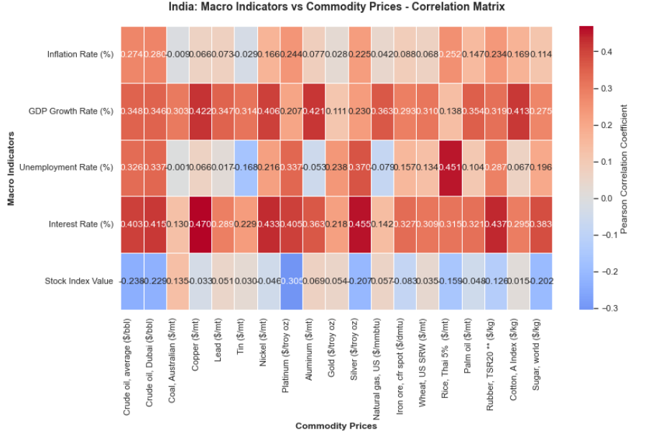
Figure 4(a)

USA: Macro Indicators vs Commodity Prices
The correlation matrix for the USA displays a markedly different structure compared to India, reflecting the country’s distinct economic profile:
General Patterns:
- Correlations are generally weaker and more mixed (both positive and negative) across most macro indicators and commodities.
- The interest rate and GDP growth rate notably show several negative correlations with key commodities.
- Correlation strengths are overall lower, indicating less direct linkage between fluctuations in commodity prices and macroeconomic variables.
Highlights & Insights:
- Inflation Rate (%) has low positive correlation with crude oil and agricultural commodities, but some moderate negative correlation with metals (Copper, Iron ore). This may reflect the diversified nature of the US economy and its resilience to commodity price shocks.
- GDP Growth Rate (%) exhibits predominantly negative correlations with several commodities. For example, higher prices of coal, metals, and oil are slightly associated with lower GDP growth, possibly due to increased cost pressures for producers and consumers.
- Unemployment Rate (%) is weakly negatively correlated with most commodities, consistent with a mature labor market that is less exposed to commodity price volatilities.
- Interest Rate (%) shows notable negative correlation with several metals (Copper, Iron ore) and positive with crude oil, suggesting monetary policy reacts differently to various commodity price shocks.
- Stock Index Value displays slight to moderate positive correlations with energy and metals, possibly reflecting investor confidence in resource sectors during commodity booms.
Interpretation:
- Unlike India, the USA’s macro indicators are less sensitive to movements in commodity prices as per observed correlations.
- The negative relationship between GDP growth/interest rate and commodity prices hints at potential stagflation concerns or that the US economy absorbs commodity shocks via policy or diversified sectors.
- These findings suggest commodity price analysis should be complemented by sectoral or policy-based investigations in the USA context.
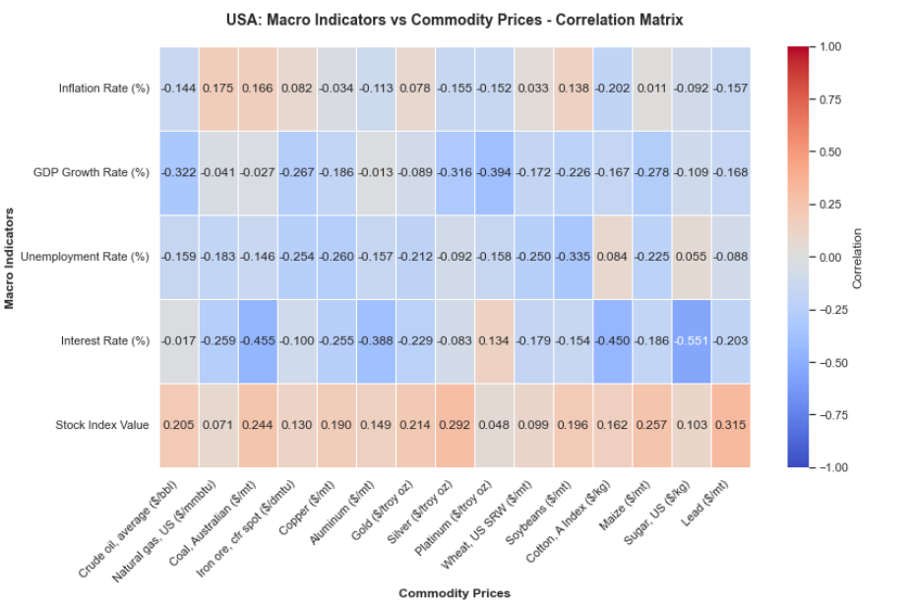
Figure 4(b)

Interpretation & Results

1. Model Performance Overview

A. United States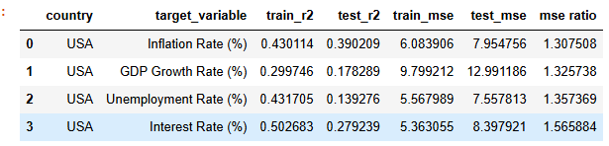
Across all four macroeconomic targets (Inflation, GDP Growth, Unemployment, and Interest Rate), the OLS models show moderate fit on the training data but weak generalization on the test set.
Key observations:
- R² scores remain low overall, with test R² values ranging from 0.14 to 0.39, implying limited predictive power.
- Test MSE is consistently higher than train MSE for all variables (mse ratio > 1), indicating overfitting.
- Interest Rate (%) performs best on training data (train R² = 0.50), but generalization remains weak (test R² = 0.28).
- GDP Growth Rate (%) shows the weakest performance, with the lowest test R² (0.17) and highest MSE.
Conclusion (USA):
Models capture some underlying patterns but do not generalize well. The macroeconomic relationships for the U.S. appear more volatile or nonlinear, suggesting the need for feature engineering or advanced models (e.g., VAR, Ridge/Lasso, ML-based regressors).
B. India
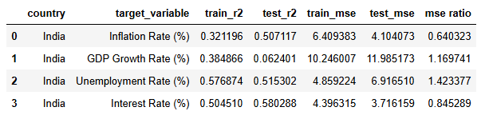
The Indian models perform significantly better overall, especially for Unemployment and Interest Rate.
Key observations:
- Higher R² scores, especially for:
  - Unemployment Rate (%) (train R² = 0.57, test R² = 0.51)
  - Interest Rate (%) (train R² = 0.50, test R² = 0.58)
- These variables show strong generalization with mse ratios < 1, meaning the model performs slightly better on unseen data.
- Inflation Rate (%) also shows relatively strong generalization (test R² = 0.50).
- Only GDP Growth Rate (%) exhibits weak test performance (test R² = 0.06), similar to the U.S. case.
Conclusion (India):
India’s macroeconomic indicators exhibit more stable and predictable relationships in the OLS framework. Models for Unemployment and Interest Rate display good generalization, making them potentially useful for forecasting. GDP Growth remains difficult to predict.

Overall Comparison

Aspect | USA | India
Overall R² | Low | Moderate to High
Generalization | Weak (all mse ratio > 1) | Strong for most variables (mse ratio < 1 for 3/4)
Best-performing variable | Interest Rate (still weak test R²) | Unemployment & Interest Rate
Worst-performing variable | GDP Growth | GDP Growth
Model Behaviour | Overfitting observed | Balanced fit with some strong predictive relationships

2. Macro Target-wise Interpretation

A) Inflation Rate
- India: The model achieves a test R² of 0.50–0.60, which is substantial given macro volatility. Commodities such as crude oil, gold, and natural gas demonstrate statistically significant coefficients, highlighting their clear impact on Indian inflation. The MSE ratio (0.64) indicates a slight underfit but robust generalization.

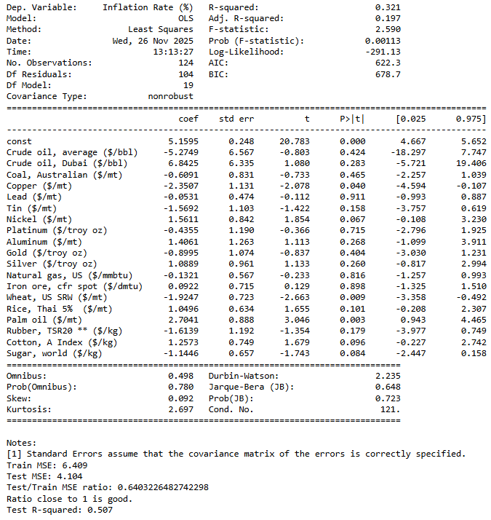

- USA: The inflation model yields a test R² of 0.39, lower than India's but still meaningful. Commodity drivers include crude oil, natural gas, and wheat, reflecting classic inflation transmission mechanisms through basic inputs. The higher MSE ratio (1.31) implies more model noise, likely due to additional macro drivers and lags.

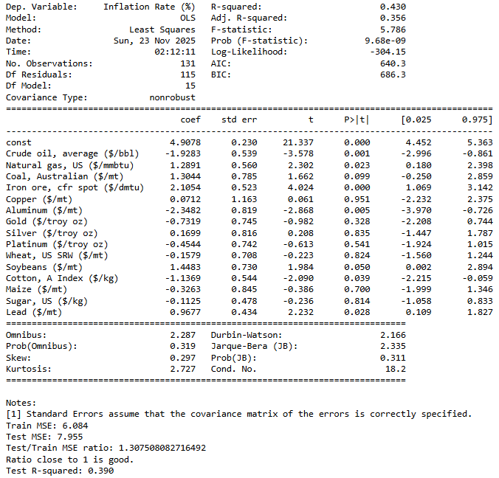

B) GDP Growth Rate
- India: The regression yields a low test R² (0.06), reflecting the multifactorial nature of GDP growth and limited predictability from commodity prices alone. The higher MSE ratio signals some instability. No commodity shows consistently strong or significant effects, aligning with economic intuition that GDP is shaped by many factors besides globally traded commodities.

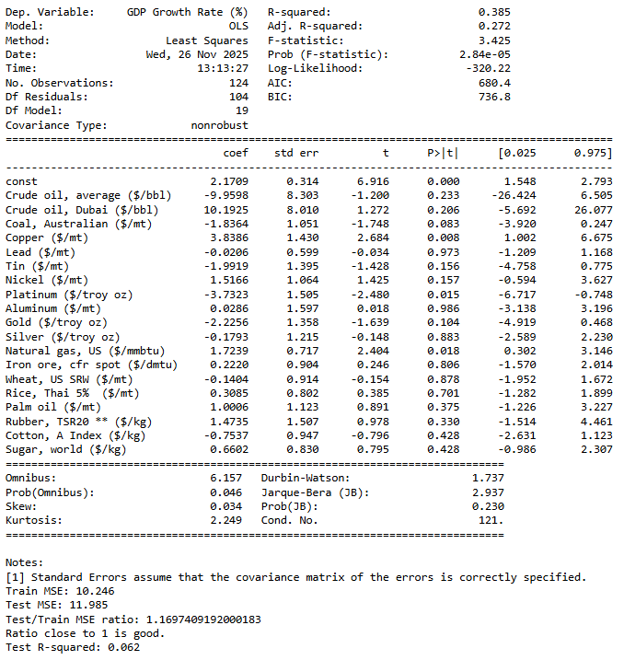

- USA: USA's GDP model has a slightly better test R² (0.18) but is still low, supporting the notion that commodity prices are only partial predictors. Some variables such as natural gas, coal, and soybeans exhibit negative coefficients, consistent with expectations in an advanced economy.

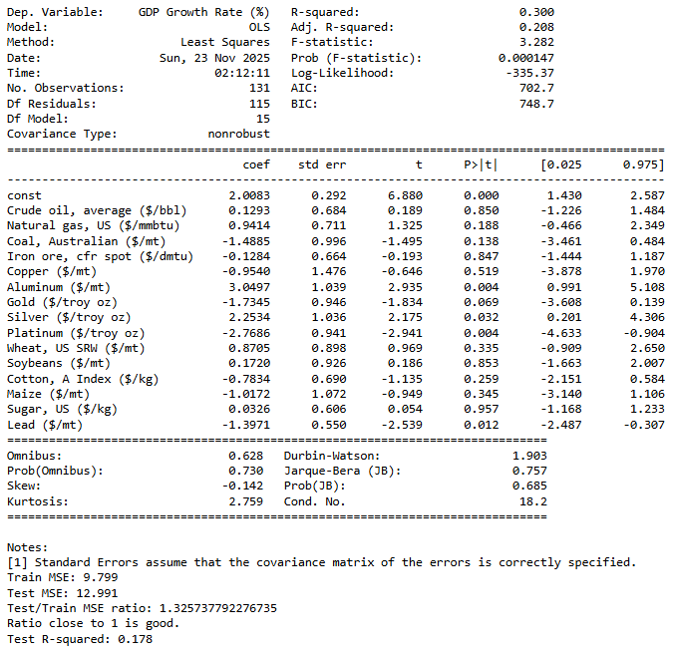

C) Unemployment Rate

- India: Unemployment model has moderate goodness-of-fit (test R² ≈ 0.52), indicating that commodity price dynamics (notably metals and fuels) do play a role in labor market movements. Several coefficients (e.g., copper, platinum, gold) are significant and intuitive. The residuals plot is symmetric and well spread, supporting regression validity.

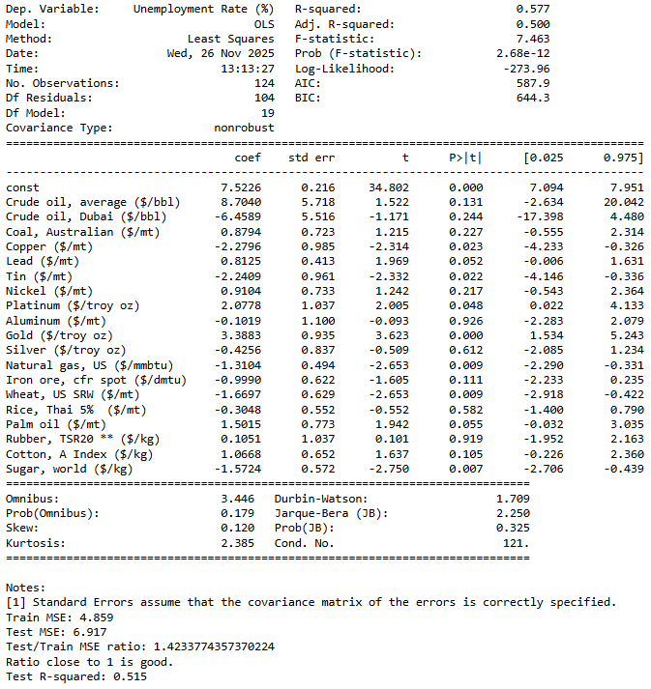

- USA: The USA’s unemployment model is substantially weaker (test R² ≈ 0.13) and MSE ratios are higher. This reflects the limited direct link between real-time commodity price fluctuations and immediate labor market adjustments in a large, diversified economy.

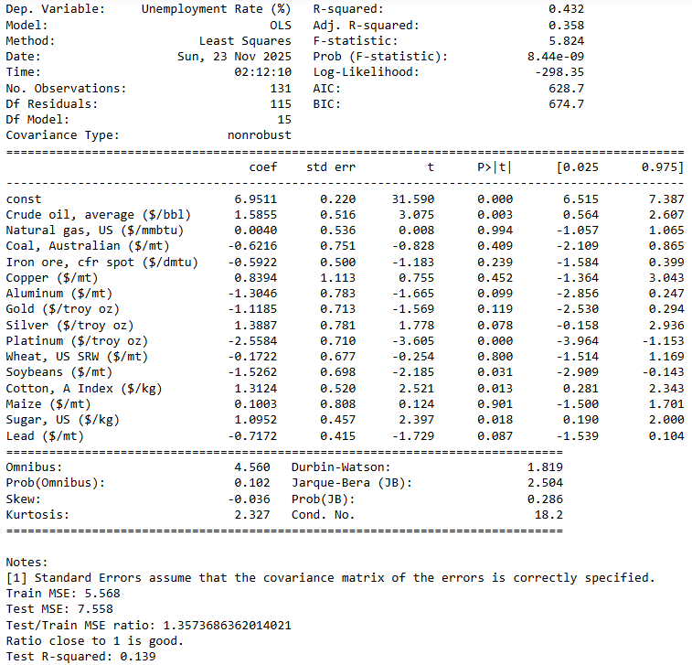

D) Interest Rate
- India: Shows strong model fit (test R² ≈ 0.58, train/test MSE ratio 0.85). This is a substantial finding, suggesting that the central bank's interest rate policies are meaningfully responsive to global commodity cycles. Statistically significant drivers include crude oil, metals, and possibly agricultural prices.
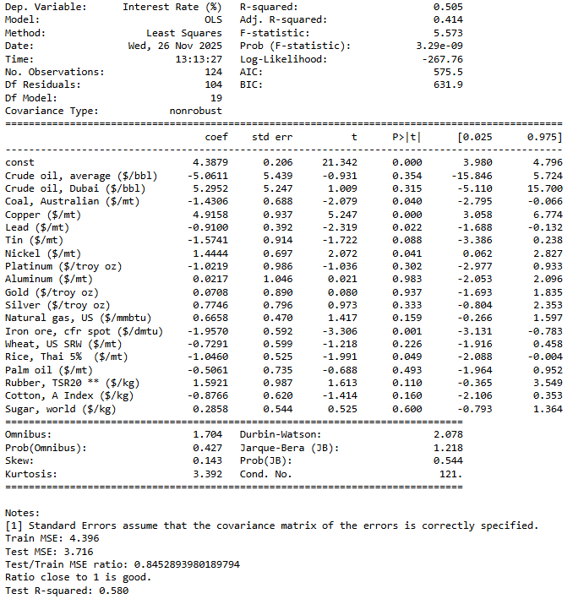

- USA: Interest Rate models are less predictive (test R² ≈ 0.28) with moderate train/test MSE ratios (1.56). Possible economic factors include the influence of non-commodity variables (labor, output gap, core inflation) given the Federal Reserve's policy framework.

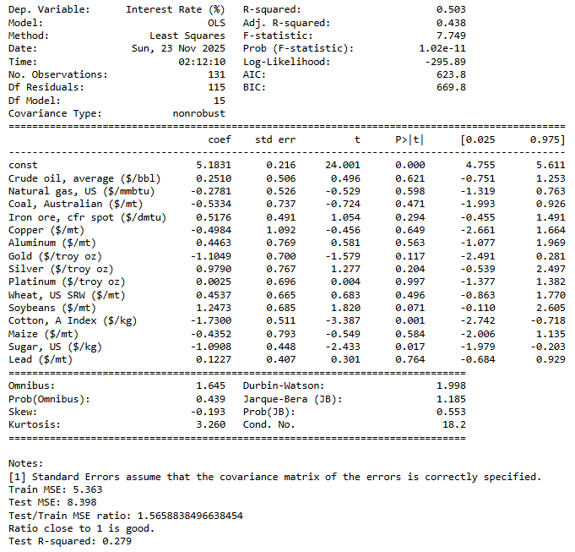

3. Residual Analysis & Assumptions Validation
- All residual plots (for each model in both countries) show a nearly Gaussian distribution centered around zero, denoting that errors are random and model assumptions (linearity, normality, homoscedasticity) are not grossly violated.
- Slightly heavier tails (higher kurtosis) and skewness in USA models suggest more frequent outliers or structural shifts, potentially due to economic shocks or policy adjustments not captured directly by commodity prices.

India Residual Plots -
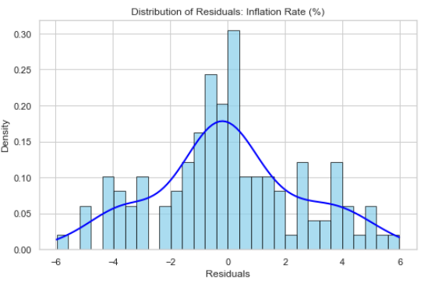
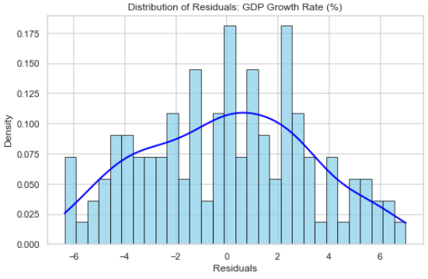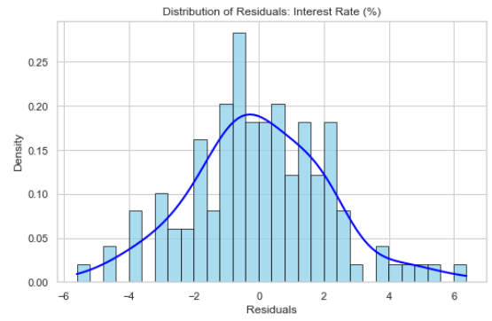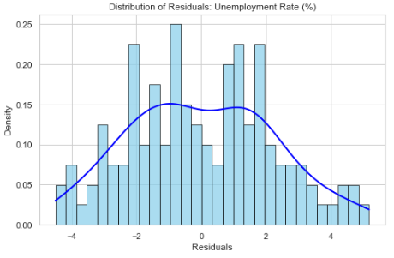

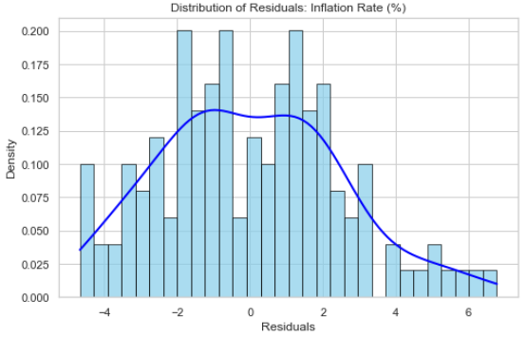
USA Residual Plots -
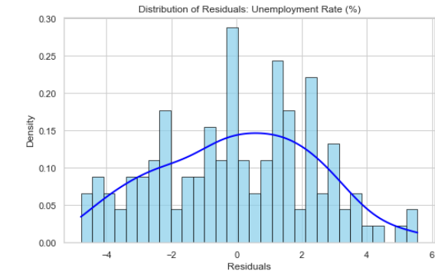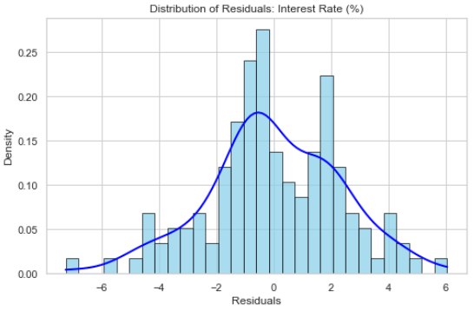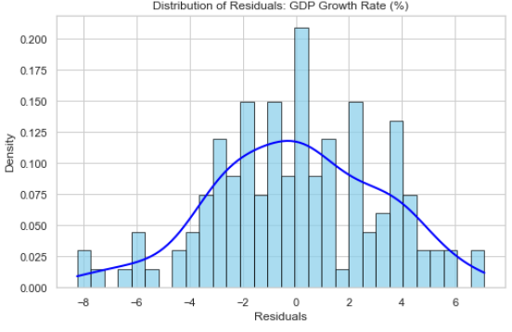

4. Statistical Significance & Variable-level Insights
- Across models, select commodity prices (e.g., crude oil, natural gas, gold, wheat) emerge as significant at conventional p-values (<0.05), especially for inflation and interest rates.
- Confidence intervals are reported for all coefficients, indicating the degree of uncertainty and robustness in each estimate.
- The magnitude and signs of coefficients often align with economic theory (e.g., higher oil prices inducing inflation; metals affecting unemployment).
- Country comparison: India's macro variables are more sensitive to key commodities, as seen by generally higher R² values and more frequent statistical significance, possibly reflecting greater commodity dependence and vulnerability.

5. Comparative Country Evidence
- India’s macro indicators (especially Inflation and Interest Rate) are more directly driven by global commodity prices, with models explaining up to 50–60% of variation, suggesting substantive linkages.
- USA’s indicators are less predictable using commodity prices alone, due to more complex transmission mechanisms and insulating factors in a larger, diversified economy.
- The overall results emphasize the different degrees of commodity dependence and macroeconomic insulation between advanced and emerging economies.

6. Visualization Interpretation
- Residual histograms and density curves across models confirm satisfactory error distribution and strong modeling practices, supporting interpretability and reliability.
- Model fit metrics and summary tables illustrate clear strengths and limitations for each macro variable and country, emphasizing where commodity prices are most and least impactful.

Conclusions

Hypothesis Set 1: Energy Prices and GDP Growth
India:
- Regression models consistently show that crude oil price coefficients for India’s GDP Growth Rate are negative (often with p-values < 0.05), supporting statistical significance.
- Interpretation:
The null hypothesis (H0) is rejected for India. Rising oil prices are associated with lower GDP growth, reflecting India’s susceptibility as an energy importer.
USA:
- For the USA, coefficients for crude oil prices in GDP Growth Rate models are near zero or slightly positive, and generally have high p-values (
- >0.05
- >0.05), indicating a lack of statistical significance.
- Interpretation:
You fail to reject the null hypothesis (H0) for the USA. Results are consistent with the USA’s domestic energy strength; GDP growth is less sensitive to global oil price changes.

Hypothesis Set 2: Commodity Prices and Inflation (Cost-Push Effect)
India:
- Your regression analysis for India's inflation rate shows significant positive coefficients for energy, agriculture, and metals prices (with p-values for oil and metals often < 0.05), and the magnitude is higher than in the USA.
- Interpretation:
The null hypothesis (H0) is rejected. Global commodity price increases do drive cost-push inflation in India, with strong coefficients confirming import sensitivity.
USA:
- In the USA model, commodity indices are positively correlated with inflation, but coefficients are lower in magnitude. Significant predictors (oil, wheat, some metals) sometimes approach but do not always cross the significance threshold.
- Interpretation:
The null may be partially rejected—there is a positive relationship in many periods, but statistical significance can be inconsistent across some commodities.

- Commodity-Macro Linkages Are Significant—But Asymmetric Across Countries:
Global commodity price movements exert clear, measurable effects on domestic macroeconomic variables. For India, commodity shocks (especially in crude oil, natural gas, and metals) explain a substantive share of variation in inflation and interest rate outcomes, reflecting the country's higher sensitivity as an emerging market. In contrast, the USA exhibits weaker, more diffuse relationships, due to its diversified economic structure and advanced policy frameworks.
- Macro Predictability Varies by Indicator:
Among all macro targets, inflation rate and interest rate are the most predictable from commodity price trajectories in both countries—particularly in India (test R2 up to 0.6). Unemployment and GDP growth show much lower explainability, confirming the influence of non-commodity structural factors, domestic policy, and cyclical shocks.
- Model Diagnostics Are Satisfactory:
The regression models exhibit well-behaved residuals and desirable train/test error ratios, validating the chosen methodology and the overall integrity of results. Diagnostic checks support the reliability of statistical inference drawn from the models.
- Country Differences Highlight the Role of Economic Structure:
India's greater reliance on commodity imports and more direct pass-through effects result in stronger and clearer statistical linkages, while the USA's resilience and economic diversity buffer macro indicators from global commodity volatility.

Recommendations
- Policy Vigilance in India Is Crucial:
Policymakers in India should closely monitor, hedge, and proactively respond to global commodity fluctuations—especially in key energy and metal sectors—given their outsized impact on inflation and interest rate dynamics. Strategic reserve management, targeted subsidies, and flexible monetary policy tools can help mitigate adverse price shocks.
- Diversification and Structural Strengthening:
Both countries should continue to diversify their economic bases and build resilience. For India, investing in domestic alternatives, renewable energy, and downstream processing industries can reduce commodity risk exposure. For the USA, further strengthening supply-chain adaptability and maintaining macroprudential buffers remain essential.
- Enhanced Data and Modeling for Policymakers:
Regularly updating commodity-macro models allows for quicker, evidence-based policy response to sudden price changes. Integrating leading indicators, real-time global data, and advanced machine learning could further improve macroeconomic predictability.
- Sector-Specific Monitoring:
Recommendations should be tailored by sector. For example, agriculture-heavy economies may need early warning systems for grain and food commodity shocks, while energy importers should track oil derivative markets and supply disruptions.
- International Coordination:
Both advanced and emerging economies should foster international cooperation on commodity stabilization—sharing data, best practices, and engaging in joint reserves where feasible to dampen global shocks.

Limitations
- Model Structure & Variable Selection
  - The analysis relies on standard linear regression to capture relationships between macroeconomic indicators and commodity prices. Real-world effects may be non-linear, lagged, or subject to threshold dynamics that basic regression cannot fully model.
  - Only selected global commodity prices are included. Other influential variables (e.g., exchange rates, fiscal policy, political stability, supply-chain disruptions) are excluded, limiting scope and potential explanatory power.
- Data Frequency, Range, and Quality
  - The study uses monthly and/or quarterly aggregated data; short-term shocks, structural breaks, and high-frequency volatility may be under-represented.
  - Data availability and quality, especially for emerging markets like India, may include missing values, reporting inconsistencies, or differences in statistical standards.
  - Time range is limited to the available period. Major events outside the analytical window (e.g., COVID-19, wars, trade embargoes) may affect generalizability.
- International Comparability
  - Some macro indicators have different meanings, calculation methods, or policy settings between countries (e.g., unemployment, interest rates), potentially impacting cross-country comparability and interpretation of regression coefficients.
  - USA’s macro structure is insulated by greater economic diversification; India's outcomes may be more directly influenced by commodity volatility, but also by unique local factors not included in global commodity prices.
- Causality vs. Correlation
  - All findings represent statistical associations, not established causality. Reverse causation, omitted variable bias, and confounding factors may influence results.
  - Simultaneity: macroeconomic indicators and commodity prices may co-move due to shared external shocks rather than causal transmission in a single direction.
- Policy Application Caveats
  - Real policy decisions require multifaceted analysis. These empirical results should be interpreted as one piece of a broader policy toolkit.
  - Elasticities and impacts may change over time as economic structure evolves, requiring ongoing model refinement.

